Design Process for Bluetooth Sensor Mount

Yixuan Xu, Xing Hao Li, Man Qiu Wu (M05)

### 1. Opportunity and Design Objectives

Our assembled rover successfully navigated through the maze from workshop 1. However, due to the rough time constraint, we realized that there are certain areas of improvement that could be easily implemented. We observed that the Bluetooth module was connected through wires and was not securely implemented to the rover body. This could lead to potential problems such as lack of durability and unstableness. Other areas of improvement include stabilizing the batteries, adding decorations to the rover, and adding extra wheels for stability. However, after several rounds of divergence and convergence, we decided that designing a Bluetooth mount was the feasible solution that also adds significant functional improvement.

The main design objectives were to improve the durability, stability, and aesthetics of the rover while also minimizing time and effort. Secondary objectives include practicing the design team’s modeling, prototyping, and fabrication skills as well as developing a mindset that prepares for the ESC204 final project. The durability of the rover should be improved since the current rover, with wires hanging everywhere and batteries without a covering case prevent the rover from any long-term usage. The stability of the rover should also be improved since the rover currently is hard to control and the Bluetooth seldom disconnects due to loosened wires. And finally, the aesthetics of the rover has tremendous opportunities for improvement since the design of the rover itself follows a minimalist philosophy.

### 2. Metrics and Criteria

1. Durability

Durability measures how long the design can be used without significant damage to its functionality. The more durable option is preferred.

1. Functionality

Functionality measures how much does the design improve the rover performance, which also includes stability, more accurate movement, ease of control, and any additional functional features. More functionality is preferred.

1. Ease of Implementation

This metric measures how much time it takes for us to build, and implement the design onto our rover. A shorter time taken for implementation is preferred.

### 3. Selected Solution

After several rounds of diverging and converging, we finalized on the following alternatives:

1. Laser-cut name tag for rover
2. 3D printed Bluetooth mount
3. 3D printed ultrasonic sensor

We decided to do a 3D printed Bluetooth mount since it is easy to implement, useful in terms of practicing 3D modeling skills, and also satisfies the 6cm x 3cm x 3cm dimension constraint. It also provides durability to our rover, as the Bluetooth would not be relying on cables, and adds a bit of aesthetics as 3D printings have various different colors.

**Material Selection**

Our method of 3D printing would be to create the CAD design on SolidWorks and send the printing through Myhal Light Fabrication Facilities using the Fused Deposition Modeling method. According to their page, they directly print the design for us so we don’t really have any space for material selection.

**Location of Attachment**

The Bluetooth device is selected to be attached to the top of the rover, on the right side of the Arduino board as viewed from behind the rover. This way, the Bluetooth device is close to the Arduino board so no additional wires were required.

**Method of Attachment**

We decided to tape the Bluetooth device to our Bluetooth mount, and then glue the Bluetooth mount onto the rover. We choose to tape the Bluetooth module onto the mount because is a replaceable component, meaning that there may be future instances where we need to substitute this device with others in case of malfunctioning. Transparent tape is easily removable and therefore, it suits our purpose well. The Bluetooth module is also light in weight and therefore tape should provide enough strength to hold the device in place. We choose to glue the Bluetooth mount onto the rover because we want the mount to be secure. Other methods of attaching the mount to the rover such as tape do not work well because they are not strong enough to hold together plastic and wood for long periods of time.

### 4. Final Design Evaluation

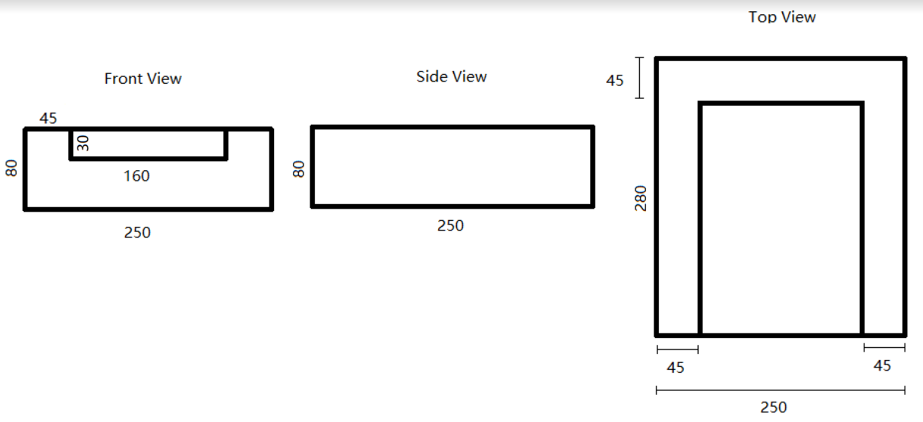

*Figure 1: Sketched Design*

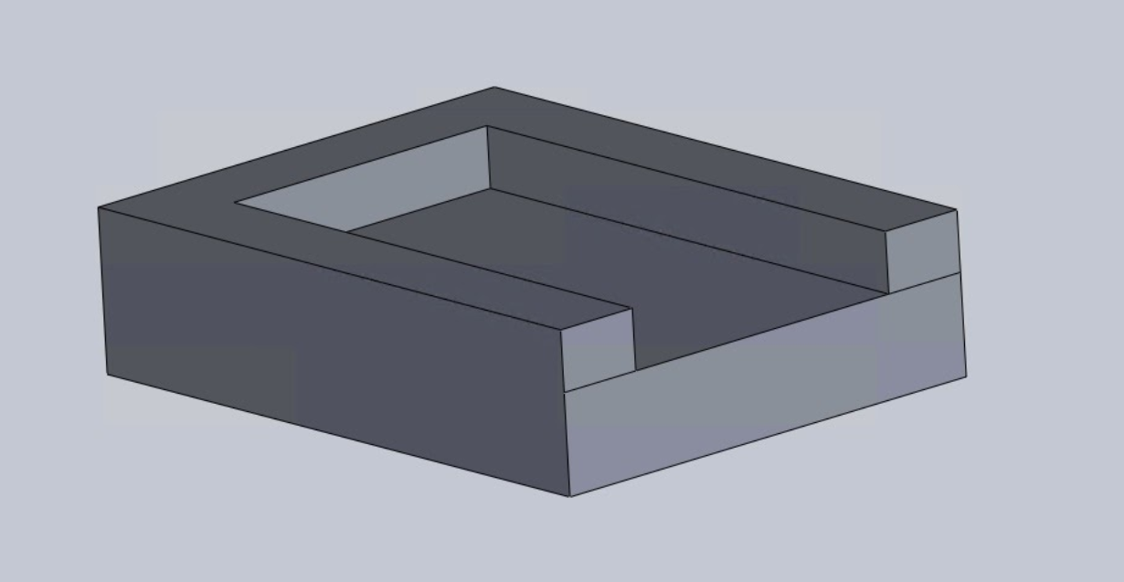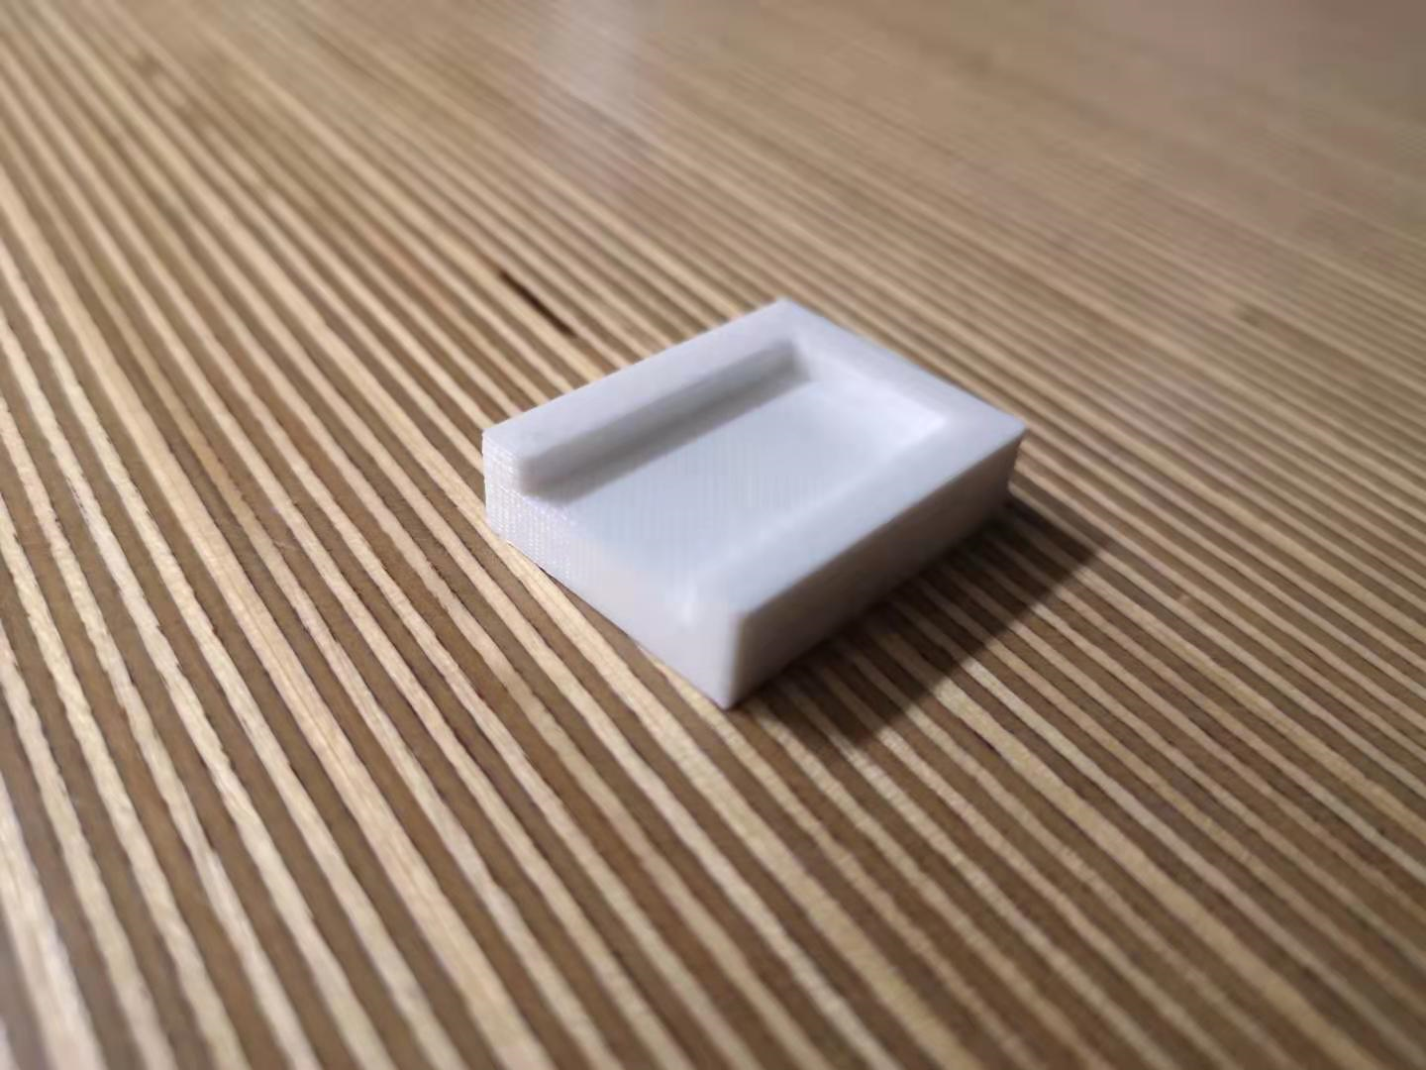

*Figure 2: CAD Design and Final Product*

Figure 2 shows a visual comparison between the CAD design and the final, 3D-printed product. As we learned in the workshop, any non-manifold geometry, overhangs with angles above 50 degrees, overly-thin features, or large and flat surfaces can cause the printed product to deviate from the original design and fail. Because our CAD design does not contain those features, it was successfully printed with no visible flaws. This proves that the bluetooth mount was designed with thorough considerations regarding the limitations of the 3D printing technology.

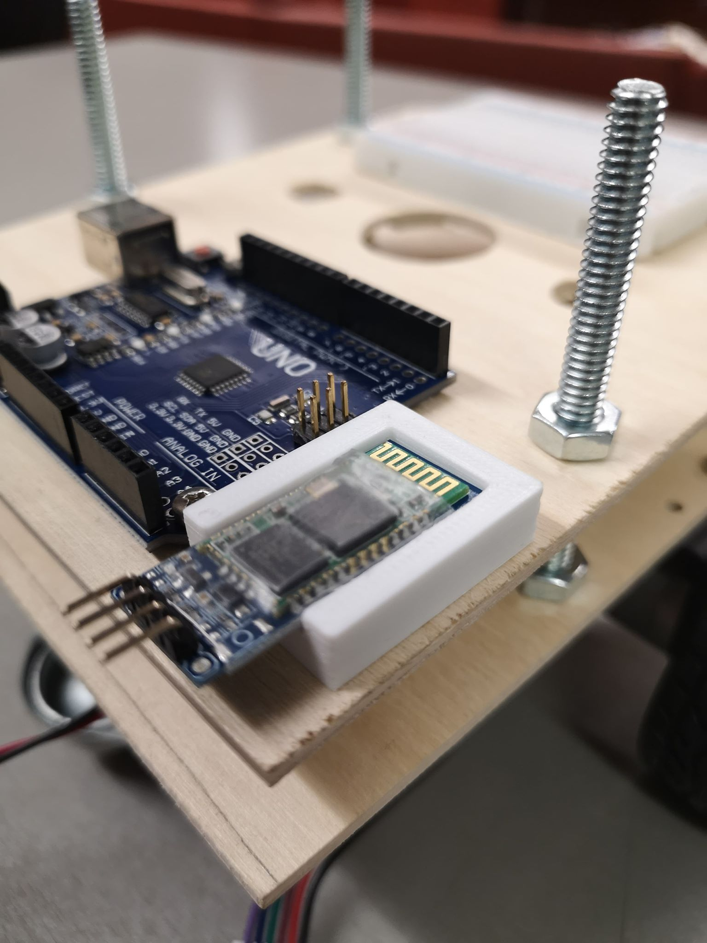

*Figure 3: Final Product with Bluetooth Module Mounted*

Figure 3 shows the finished product mounted onto the rover with bluetooth module attached. During a brief testing process with the rover in operating motion on a smooth surface in Myhal, we found that the bluetooth mount was functional without significant damage to its functionality and never failed. Not only was the operation to attach the bluetooth module easy to implement, the mount also held the bluetooth module securely in place. This proves that the module design achieved a high rating of functionality, ease of implementation, and durality.

However, this design still has room for potential improvement. Mainly, while the use of tape to secure the module is secure throughout the testing, it can possibly fail under vibrations when the rover passes through a difficult terrain. Moreover, the strength of tape we used wears off after being peeled off over time, and therefore would need frequent replacement if the module is constantly taken out. These considerations mean that while the design performs well in all three criteria, it still has room for improvement in terms of ease of implementation.